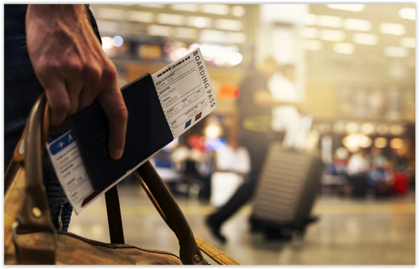

**Are you considering studying in Poland?**

**Contact POL & NILE and increase your chances of success!**

### 

### We will help you start your studies in Poland !!

|  |  |  |  |  |
| --- | --- | --- | --- | --- |
| **call us** | | | **Write to us** | |
| **PL/+48 575661664**  **EG/+201557.709.919**  **We are waiting for your call!** |  | [info@polandnile.com](https://poczta.onet.pl/NowaWiadomosc/Do/QlIkBFQ6QUFhIVRZX192dnQBeCtCchExHQI1ZgcVVEwyBh0ACFpYV0gHHB5BVFRGXy5WVkRYVVhWF1RBQUtwQlVUSA0eC1ZndElXWlI9IChNJw9JI0w1VlZoZgRhARYa)  **We are available in the traditional way!!** | |

**What do studies in Poland look like and how long do they last?**

• Studies in Poland are based on the Bologne system, which means that they are divided into three levels - bachelor studies (1st cycle), master's studies (2nd cycle) and doctoral studies (3rd cycle). The duration of undergraduate studies is three years, with the exception of technical specializations taught at polytechnic universities and completed with the title of engineer (equivalent to a bachelor's degree) - they last for seven semesters, i.e. three and a half years. Master's studies usually last for two years. Some fields of study are taught in the form of uniform Master's studies lasting for five or six years, without a division into bachelor's and master's degrees. This applies to several fields of study, e.g. law and medicine.

• Studying at the third-cycle, i.e. doctoral studies, lasts for several years and consists of much  
 in-depth study in a narrow field.

• The academic year in Poland is divided into two semesters: winter and summer.

• Classes in the winter semester start at the beginning of October and last until the end of January.

• Classes in the summer semester start from mid-February and last until the end of June.

• Part-time studies are offered in the form of evening or weekend studies



**How much do studies in Poland cost?**

The cost of studying in Poland for foreigners depends on factors such as the choice of university (private or public), the choice of a major and specialization, the choice of language (Polish or English) and the choice of the form of study (full-time, extramural or online).

Are there free of charge studies for foreigners in Poland?



**Foreigners can study in Poland for free if:**

• they are citizens of a European Union member state, Switzerland or a member state of the European Free Trade Association (EFTA)

• they are persons who have been granted a permanent residence permit or a status of long-term resident of the European Union

• they hold a Pole's Card or are persons who have been issued a decision confirming their Polish origin

• they are spouses, ascendants or descendants of a citizen of the Republic of Poland, living in the territory of the Republic of Poland

• they are persons who have been granted a temporary residence permit due to circumstances

• they are persons who have the refugee status granted in the Republic of Poland or they exercise temporary protection or subsidiary protection on the territory of the Republic of Poland

• have a certificate confirming the knowledge of Polish as a foreign language at least at the C1 language proficiency level.

**What is the application process for studies for foreigners in Poland?**

To apply for an undergraduate program, you must first provide a high school diploma with grades, and for a graduate application, a bachelor's degree diploma. In addition, almost every university in Poland requires apostille documents - this is a stamp that gives legal status to any official document. Documents must be translated into Polish by a sworn translator. More detailed information on sending documents to the Polish university can be found directly on the websites of the universities you are interested in, while on our website you will find detailed information on applying to the University of Technology in Katowice.

**When does enrollment for studies in Poland start?**

Each university individually sets the deadlines for submitting applications. But most often, enrollment for studies begins in early May and lasts until July. However, this is not a rule, and recruitment at some universities starts in March. If the university still has vacancies, there is an additional admission process in August.

**Important for students who want to continue their studies in Poland, but have started them at other universities!**

The decision of the university to admit a candidate to study for the continuation purpose is made on a case-by-case basis, after the student submits a complete set of documents. The analysis will include, inter alia, information such as the current university, field of study and program of study (program differences will be assessed).

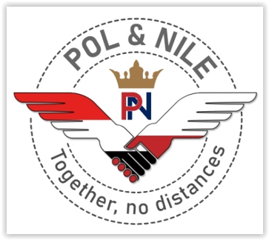

**Choose comprehensive support or use the help you need!**

► We have prepared a schedule of activities for you (in the form of a table), which you will stick to during the recruitment at the WST in Katowice. Thanks to this, you will not get lost and you will correctly upload all documents to the university system in the right order and time.

► You can contact us for assistance with the application and recruitment process for studies at the JTS; we will check if the registration process to the application system was correct and if you do not need to conduct talks explaining your situation with the university authorities

► If necessary, we will prepare letters, forms and applications on your behalf

► If you are interested in obtaining an EU driving license, we will help you find a suitable driving school in English

► We will help you find accommodation for the duration of your studies at WST

► We will provide you with support during your studies at the WST

► If you meet the conditions to study in Poland for free and choose the WST - we will help you with this

**If you decide to study at WST, contact us!**

**We look forward to hearing from you!**

WRITE TO US !



**POL&NILE**

**MOHAMED SALEM**

**ANNA POLOCZEK**